***DESIGN AN LED FLASHER***

***LED Flasher Diagram:***

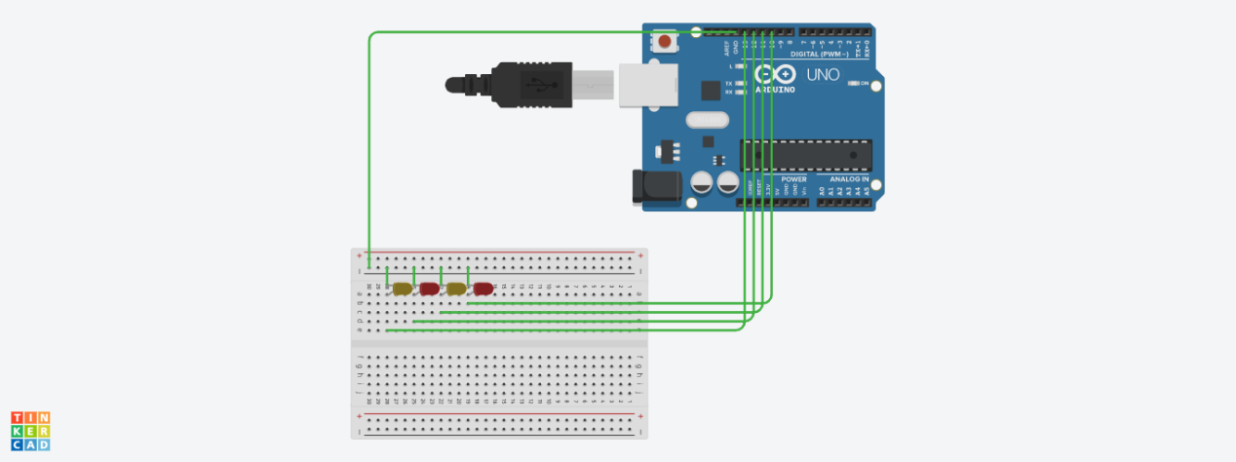

***Theory:***

In this project, we will go over how to build an Arduino LED chaser circuit.

We will use a standard Arduino board, doesn't matter which, and connect it so that it flashes the LED’s a certain amounts of times on and off repeatedly to create an LED chaser circuit.

An Arduino is a self-contained microcontroller. Therefore, it can be programmed via the language processing to turn various LEDs on for a certain period of time and turn them off for a certain period of time- over and over. To control the amount of time the LED will be on and the amount of time it will be off can easily be decided by our software code.

Once the Arduino board is connected to a computer via USB, it has 5V of power. It gets power via the USB. The LEDs are then connected to its digital output pin. All we must then do is write our program.

* ***CONCEPTS USED:***

1. Knowledge about Aurdino UNO
2. Coding for aurdino
3. Breadboard circuits

* ***LEARNING AND OBSERVATIONS:***

1. Connections in Breadboard and wiring.

2. How to control arduino and its coding.

3. Use of multimeter for continuity.

***OBSERVATION:***

**1.** Blinking of LEDs in chasing form.

2. Relation between software and hardware.

***PROBLEMS & TROUBLESHOOTING:***

1. To select the right port and type of arduino
2. To check the loose connections
3. To check the connections according to the codes
4. To check the continuity of the circuit
5. To check the flow of current in the circuit

***PRECAUTIONS:***

1. Handle tools carefully
2. Wear gloves
3. Do not connect arduino till the circuit is complete

***OUTCOMES:***

1. LEDs glows in a chasing pattern
2. It can be used as for decorating purpose